I’ve been wanting to do a showcase website for a while now. A place where I can post all my multimedia work. Right now, for me that place is Instagram but it’s so unprofessional when a employer asks for my portfolio and I give a link to my Instagram or YouTube account meanwhile everyone in my industry has a working website. This website will not only showcase my work but in turn be one of my “works.”

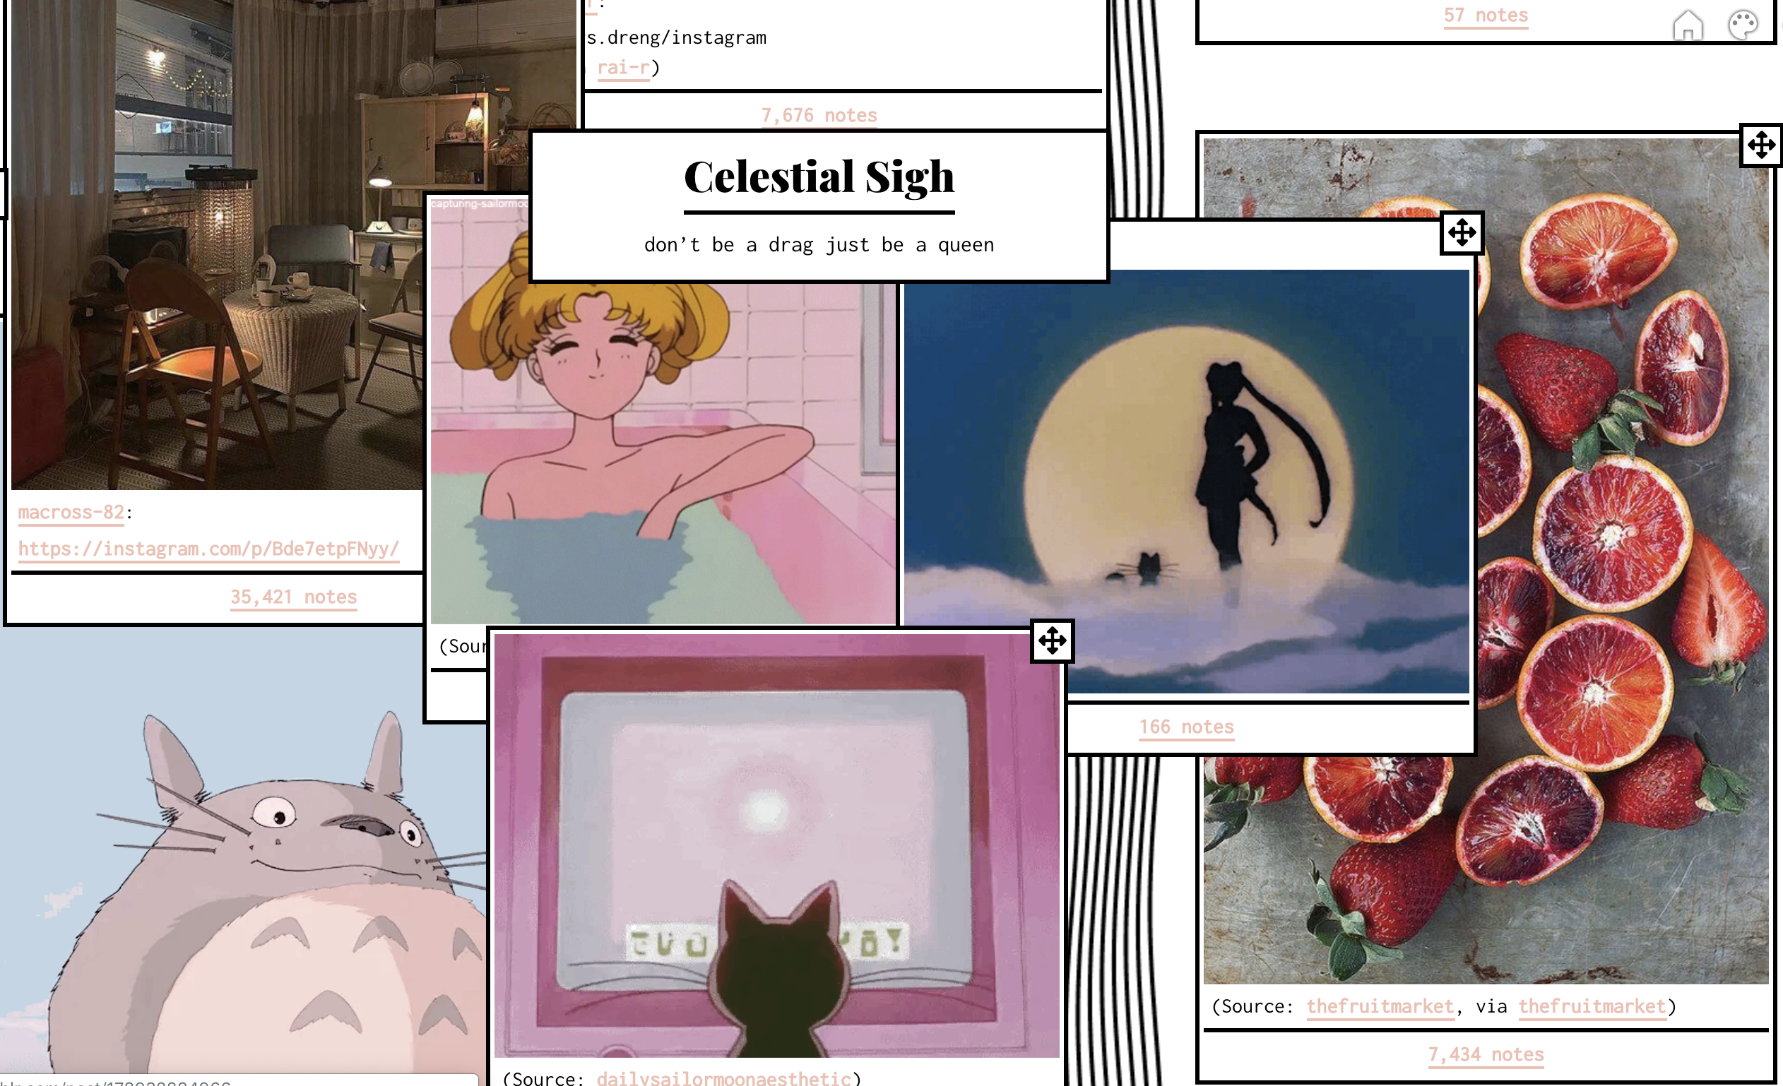

My Work

(entire website is minimalist design except the boxes which will be over colorful overlays)

Celestial Sigh

(Header of website must float a little)

Who Am I

(Maybe these boxes are different shapes…honey combs or cubes or drawn on boxes or clouds)



Bio/resume/cover letter

Profile Picture

(My photography)

designs

videos